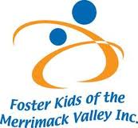
Thank You!

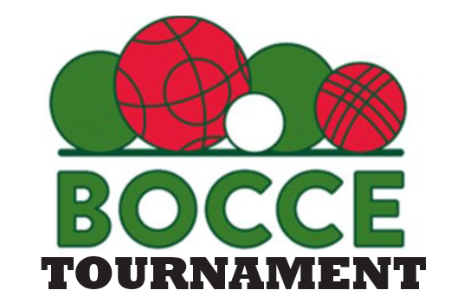
Lane Sponsorship
We are a 501©3 non-profit organization, dedicated to serving the needs of foster children in the Merrimack Valley, including Haverhill, Lawrence, Methuen, Andover and North Andover. With hundreds of foster children in our local area, they need role models who can make a difference in their lives.
Through the efforts of the organization, together with our community, our goal is to bring positive influence into the lives of these children and support them as they grow. We offer a range of programs for local foster children of all ages. We work closely with Department of Children and Families (DCF) to make sure our programs are complementary and needed and do mot overlap with state and federal funded programs.

Lane sponsors for $200 each lane. Your name/banners will be posted on the lane during the Tournament. Your company name and logo will be posted in our social media sites.

All proceeds to benefit the our kids

April 27, 2024
8:30 am Registration
9:00 pm – 4:00 pm tournament

Sons of Italy
459 Merrimack St
Methuen, MA 01844

Register your teams or get a lunch ticket by
Email: giordanoeileen@gmail.com
Call: (978) 771-2150

Company Name:__________________________________________________________________

Contact Person:_______________________________________ Phone #:____________________

Sponsorship Level:_____________________________________ Logo Enclosed:________________

