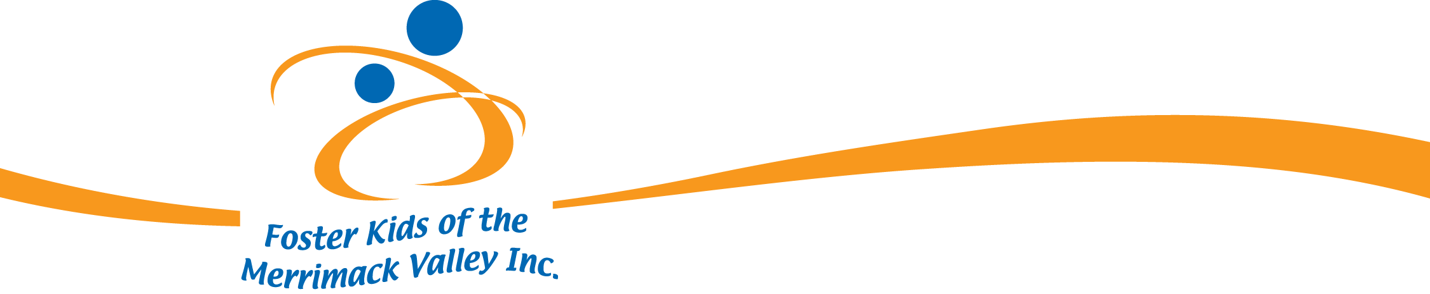

June 2026

Dear Community Partner:

On Friday, August 14, 2026 the Foster Kids of the Merrimack Valley, Inc. will host its
10th Annual Benefit Concert at the Blue Ocean Music Hall in Salisbury, MA., featuring
“The Heavy Hitters” who are a powerhouse collective of veteran musicians whose chemistry was forged onstage long before they ever became a band. They have evolved into a dynamic ensemble with over 150 years of combined experience with hundreds of songs that can be delivered on request. Known for their elite musicianship, deep catalog and electrifying live energy. Foster Kids of the Merrimack Valley is honored with this exclusive performance to benefit our kids.

All proceeds go directly to the FKMV projects including our Annual Christmas party, Easter Party, Foster Parent’s Appreciation Party, the Pack It Up Program, Helene Giordano Memorial Scholarship Program, Financial Aide Program and numerous Camperships & Sponsorships.

Please help our kids by becoming a sponsor of this event. Your investment in the youth of the Merrimack Valley foster care system will have long-lasting effects on their lives and our community.

Sponsorships available:

Event $2500.00 -receive 6 tickets to the show, Logo on all literature, website & social media
Angel $1000.00 -receive 4 tickets to the show, Logo on event signage, website & social media
Guardian $500.00 -receive 2 tickets to the show, Logo on event signage, website & social media
Mentor $250.00 - Logo on event signage, website & social media

All sponsors will be recognized at the concert.

For any questions or more information please call 978-771-2150 or giordanoeileen@gmail.com.

The Foster Kids of the Merrimack Valley, Inc. is a 501(c) 3 non-profit organization EIN 26-1347672. Your gift is tax deductible.

Our kids are full of promise and potential and we as a community have an obligation to take an active role in their future. Together we can all succeed.

Sincerely,

Larry F. Giordano
President

