Calling all friends of the
Foster Kids of the Merrimack Valley

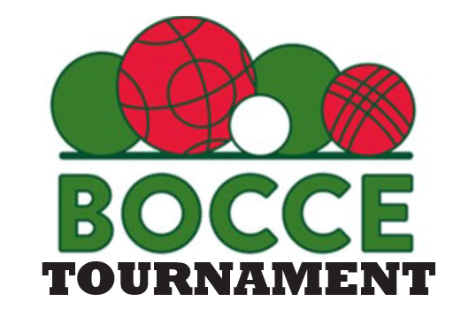

All Proceeds to Benefit our KIDS

April 27, 2024
8:30 am registration
9:00 AM – 4:00 pm tournament

Sons of Italy
459 Merrimack St
Methuen, MA 01844

Costs: Bocce - $40 per person for teams of 4
Includes lunch and play
$15 spectator lunch tickets

Come make some new friends, eat good food, win some prizes & support our kids!

Register your teams or get a lunch ticket by
Email: giordanoeileen@gmail.com
Call: (978) 771-2150
Or mail application Below: Foster Kids M/V, P.O. Box 2166, Methuen, MA 01844
Name of Team:_________________________________________ Payment enclosed:_______

Contact Person:____________________________ Phone: _____________________________

Team Members: 1-________________________ 2-_________________________________
3-_________________________ 4- _______________________________

